Ideation Phase
Define the Problem Statements

Date | 18 FEB 2026
Team ID | LTVIP2026TMIDS74685
Project Name | Visualizing Housing Market Trends: An Analysis of Sale Prices and Features using Tableau
Maximum Marks | 2 Marks

Customer Problem Statement Template:
Create a problem statement to understand your customer's point of view. The Customer Problem Statement template helps you focus on what matters to create experiences people will love.
Problem  Statement  (PS) |  | I am (Customer) |  | I’m trying  to | But | Because |  | Which makes me feel
PS-1 |  | A busy working professional |  | Quickly find a suitable area to buy a house | I don’t have time to analyze lengthy reports or datasets | The dashboard lacks a simple summary or  recommendation feature |  | Overwhelmed and indecisive
PS-2 |  | A dataset  user exploring market trends |  | Visualize how  different features impact house prices | Some data points are missing or outdated | The dashboard isn't pulling from live or recent data sources |  | Skeptical and frustrated
A well-articulated customer problem statement allows you and your team to find the ideal solution for the challenges your customers face. Throughout the process, you’ll also be able to empathize with your customers, which helps you better understand how they perceive your product or service.

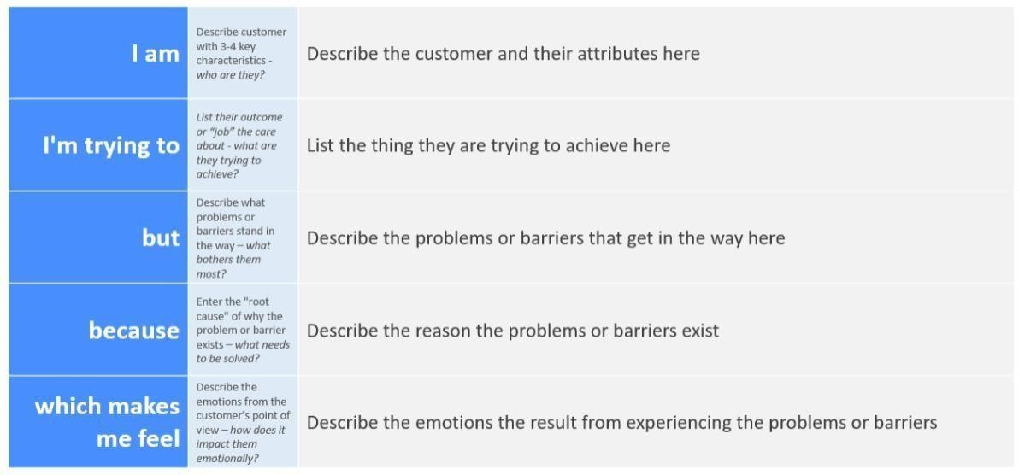
Reference: https://miro.com/templates/customer-problem-statement/
EXAMPLE:
Visualizing Housing Market Trends: An Analysis of Sale
Prices and Features using Tableau

I am | A data-driven homebuyer or real estate investor who values informed decision-making, is time-constrained, and lacks technical skills to process raw data.
I’m trying to | Understand how property features and locations impact sale prices to make confident buying or investment decisions.
But | I find it hard to interpret raw data and correlate different housing features due to lack of visual clarity or missing insights.
Because | The available dashboards are not intuitive, lack interactivity, and often do not reflect up-to-date or easily comparable information.
Which makes me feel | Frustrated, uncertain, and less confident in making a financial decision that could impact my future

